PROJECT REPORT ON

**Parking Management System**

SUBMITTED IN PARTIAL FULFILMENT OF THE

REQUIREMENTS FOR THE AWARD OF THE DEGREE OF

BACHELOR OF SCIENCE INFORMATION TECHNOLOGY

**DESIGNED AND DEVELOPED**

BY

**NITYANAND KANNAN SEAT NO: 4022556**

UNDER THE GUIDANCE OF

**Ms. NARMETA VANITA**

DEPARTMENT OF INFORMATION TECHNOLOGY

**S.I.E.S COLLEGE OF, COMMERCE & ECONOMICS**

**SION (East)-400 022**

**UNIVERSITY OF MUMBAI**

**(2016-2017)**

**UNIVERSITY OF MUMBAI**

**2016-2017**



**SIES COLLEGE OF COMMERCE AND ECONOMICS**

**NAAC Reaccredited “A” Grade ISO 9001:2008 Certified**

**Project Certificate for B.Sc.I.T. Students**

This is to certify that the project entitled Parking Management Systemundertaken by

**Mr. NITYANAND KANNAN SEAT NO: 4022556**

In partial fulfillment of B.Sc.I.T. Degree (Semester VI) Examination had not submitted for any other examination and does not form part of any Other Course undergone by the candidate.

It is further certified that he has completed all required phase of the Project.

**Internal Guide External Examiner Head of Department**

**Content Table**

|  |  |  |
| --- | --- | --- |
| **Sr.no** | **Title** | **Page** |
| **1** | **Introduction** | 6 |
| **2** | **Main Report** | 8-13 |
| **2.1** | **Objectives & Scope** | 9 |
| **2.2** | **Definition of Problem** | 10 |
| **2.3** | **System Requirement Phase** | 11 |
| **2.3.1** System Requirements | 13 |
| **2.4** | **System Analysis Phase** | 14-15 |
| **2.4.1** Information Gathering | 15 |
| **2.5** | **System Planning Phase** | 16-21 |
|  | **2.5.1** Process Model | 17 |
| **2.5.2** Feasibility Study | 19 |
| **2.5.3** Gantt Chart | 20 |
| **2.6** | **System Design Phase** | 22-30 |
|  | **2.6.1** ER Diagram | 23 |
| **2.6.2** Data Flow Diagram | 26 |
| **2.6.3** Class Diagram | 27 |
| **2.6.4** Use Case Diagram | 28 |
| **2.6.5** Activity Diagram | 29 |
| **2.7** | **System Implementation Phase** | 31-40 |
|  | **2.7.1** Cost Benefits Analysis & Economic Feasibilities | 32 |
| **2.7.2** User Interface | 34 |
| **2.7.3** Database Snaps | 39 |
| **2.8** | **Maintenance** | 41 |
| **2.9** | **Testing** | 44 |
| **2.1O** | **Test Reports** | 47 |
| **2.11** | **Conclusion** | 50 |
| **2.12** | **Future Enhancement** | 52 |
| **2.13** | **Annexure** | 54-57 |
|  | **2.13.1** DATA Dictionary | 55 |
| **2.13.2** Bibliography | 57 |

**ACKNOWLEDGEMENT**

I thank the people who were a part of this project in numerous ways, people who gave their unending support right from the stage the project idea was conceived.

The four things that go on to make a successful endeavor are dedication, hard work, patience and correct guidance.

I would like to thank our principle **DR. KINNARRY THAKKAR** who has always been the source of inspiration.

I also thankful to **Mrs. BHAVINI SHAH** our coordinator for all the help she has rendered to ensure the successful completion of the project.

I take this opportunity to offer sincere thanks to **Ms. NARMETA VANITA (your guide name)** who was very much kind enough to give us an idea and guide us throughout our project work.

I also thankful to **Ms. NARMETA VANITA** and **Mrs. VARSHA** **DHANAWADE** for helping us out in Project Documentation.

I thankful to all teaching staff (I.T) who shared their experience and gave their suggestion for developing our project in better way.

Last but not the least i would like to thank all our friends and family and family members for their support, and all others who have contributed to the completion of this project directly or indirectly.

**INTRODUCTION**

**Introduction**

Parking management system for managing the records of the incoming and outgoing vehicles in an parking house

It’s an easy for Admin to retrieve the data if the vehicle has been visited through number he can get that data **.**

Now days in many public places such as malls, multiplex system, hospitals, offices, market areas there is a crucial problem of vehicle parking. The vehicle parking area has many lanes/slots for car parking. So to park a vehicle one has to look for all the lanes. Moreover this involves a lot of manual labour and investment. Instead of vehicle caught in towing the vehicle can park on safe and security with low cost.

Parking control system has been generated in such a way that it is filled with many secure devices such as, parking control gates, toll gates, time and attendance machine, car counting system etc. These features are hereby very necessary nowadays to secure your car and also to evaluate the fee structure for every vehicles entry and exit

The objective of this project is to build a Vehicle Parking management system that enables the time management and control of vehicles using number plate recognition. The system that will track the entry and exit of cars, maintain a listing of cars within the parking lot, and determine if the parking lot is full or not. It will determine the cost of per vehicle according to their time consumption.

**MAIN REPORT**

**2.1 Objectives :**

We can park our vehicle in our own slot by paying.

* Because of that there is no towing problems.
* And our vehicle has been parked as a secure condition.
* There is no risk for vehicle owner for parking the car.
* In case of any damages and problem of vehicle that will claim by parking management.
* As the world is facing many threads daily, robberies are done easily with no track to trace, bomb blasts occur with the use of vehicle, so if a proper system is adopted each and every record can be saved and anyone can be track easily therefore mainly is to make a better and fast software, most important user-friendly
* Maintain records in short time of period.
* Determines the parking area is full or not.
* Enhances the visitor’s experience.

**Scope**:

In the modern age. Many people have vehicles. Vehicle is now a basic need. Every place is under the process of urbanization. There are many corporate offices and shopping centers etc. There are many recreational places where people used to go for refreshment. So, all these places need a parking space where people can park their vehicles safely and easily. Every parking area needs a system that records the detail of vehicles to give the facility. These systems might be computerized or non-computerized. With the help of computerized system we can deliver a good service to customer who wants to park their vehicle into the any organization’s premises.

Vehicle parking management system is an automatic system which delivers data processing in very high speed in systematic manner. Parking is a growing need of the time. Development of this system is very useful in this area of field. We can sell this system to any organization. By using our system they can maintain records very easily. Our system covers the every area of parking management. In coming future there will be excessive need of Vehicle parking management system.

**2.2 Definition of problem:**

* Now a days in parking like valet parking they maintain just with the tokens and they have records the vehicle details in books so that during some critical situations like police enquiry of terrorist car or vehicle roberrer that case it is difficult to find the details of particular vehicle but in this case is easy to find in 1 to 2 seconds
* By parking the vehicle in public place the vehicle can be claimed by towing person but in this case there is no towing problems and no need to give fine for anything we can park our vehicle with securely.

2.3 **SYSTEM REQUIREMENT PHASE**

1. **Project Title :**

Parking Management System

1. **Technology:**

* **Front End: Asp.net with C#**

**Microsoft Visual Studio** is an [integrated development environment](https://en.wikipedia.org/wiki/Integrated_development_environment) (IDE) from [Microsoft](https://en.wikipedia.org/wiki/Microsoft). It is used to develop [computer programs](https://en.wikipedia.org/wiki/Computer_program) for [Microsoft Windows](https://en.wikipedia.org/wiki/Microsoft_Windows), as well as [web sites](https://en.wikipedia.org/wiki/Web_site), [web applications](https://en.wikipedia.org/wiki/Web_application) and [web services](https://en.wikipedia.org/wiki/Web_service). Visual Studio uses Microsoft software development platforms such as [Windows API](https://en.wikipedia.org/wiki/Windows_API), [Windows Forms](https://en.wikipedia.org/wiki/Windows_Forms), [Windows Presentation Foundation](https://en.wikipedia.org/wiki/Windows_Presentation_Foundation), [Windows Store](https://en.wikipedia.org/wiki/Windows_Store) and [Microsoft Silverlight](https://en.wikipedia.org/wiki/Microsoft_Silverlight). It can produce both [native code](https://en.wikipedia.org/wiki/Native_code) and [managed code](https://en.wikipedia.org/wiki/Managed_code).

Visual Studio includes a [code editor](https://en.wikipedia.org/wiki/Code_editor) supporting [IntelliSense](https://en.wikipedia.org/wiki/IntelliSense) (the [code completion](https://en.wikipedia.org/wiki/Code_completion) component) as well as [code refactoring](https://en.wikipedia.org/wiki/Code_refactoring). The integrated [debugger](https://en.wikipedia.org/wiki/Microsoft_Visual_Studio_Debugger) works both as a source-level debugger and a machine-level debugger. Other built-in tools include a forms designer for building [GUI](https://en.wikipedia.org/wiki/GUI) applications, [web designer](https://en.wikipedia.org/wiki/Web_designer), [class](https://en.wikipedia.org/wiki/Class_(computing)) designer, and [database schema](https://en.wikipedia.org/wiki/Database_schema) designer. It accepts plug-ins that enhance the functionality at almost every level—including adding support for [source-control](https://en.wikipedia.org/wiki/Source_control) systems (like [Subversion](https://en.wikipedia.org/wiki/Subversion_(software))) and adding new toolsets like editors and visual designers for [domain-specific languages](https://en.wikipedia.org/wiki/Domain-specific_language) or toolsets for other aspects of the [software development lifecycle](https://en.wikipedia.org/wiki/Software_development_lifecycle) (like the [Team Foundation Server](https://en.wikipedia.org/wiki/Team_Foundation_Server) client: Team Explorer).

* **Back End: SQL server 2008**

**Microsoft SQL Server** is a [relational database management system](https://en.wikipedia.org/wiki/Relational_database_management_system) developed by [Microsoft](https://en.wikipedia.org/wiki/Microsoft). As a [database server](https://en.wikipedia.org/wiki/Database_server), it is a [software product](https://en.wikipedia.org/wiki/Software_product) with the primary function of storing and retrieving data as requested by other [software applications](https://en.wikipedia.org/wiki/Software_application)—which may run either on the same computer or on another computer across a network (including the Internet).

Microsoft markets at least a dozen different editions of Microsoft SQL Server, aimed at different audiences and for workloads ranging from small single-machine applications to large Internet-facing applications with many [concurrent users](https://en.wikipedia.org/wiki/Concurrent_user)

1. **Modules**

**a).Data Records**

**Staff records**: - It helps to provide details of staff that uses the Vehicle parking management System. It provides the descriptions of staffs like:  
-Staff first, middle and last name  
-Address   
-Contact Number   
-Gender.

**User Records**: - This record helps for the authorization for using Vehicle Parking Management System. It Provides the Username and Password for the User (staff).It also includes the level of authority that means it separates the normal users and administrator.

**Vehicle Records**: - This most important record which focuses in our Vehicle Parking Management System. It stores the essential Vehicle records like:  
-Vehicle Number  
-Vehicle Type  
-Vehicle Entry Time  
-Vehicle Exit Time

**b).Reports**

**Vehicle Parking Detail**: - This report is very essential in this system. This report provides a brief summary of vehicle activities. It shows the overall Entry and Exit time. It shows the User at time of Entry and Exit .It also provides the facility for examining the total vehicle details according to date wise.

**Transaction Detail**:-This report will show the Transaction between the customer and the System. . It shows the cost of the vehicle after using the facility of parking. It will show the number of transaction by date wise. It will also have User at time of the Transaction.

* + 1. **Hardware and software requirement**

|  |  |
| --- | --- |
| PROCESSOR TYPE | Pentium IV or above for optimum performance. |
| SYSTEM RAM | 1.00GB and Above |
| INPUT DEVICE | BASIC KEYBOARD AND TOUCH PAD |
| OUTPUT DEVICE | STANDARD COLOR MONITOR |
| OPERATING SYSTEM | WINDOWS 7,8 |
| FRONT END | VISUAL STUDIO 2015 |
| BACK END | SQL SERVER 2008 |

**SYSTEM ANALYSIS PHASE**

1. **Information gathering**

Information gathering is done by interviewing the users and reviewing the existing documents. For the development of Parking management system a lot of research and important input from various website and application user was needed. Hence the following questionnaires were provided to them and hence te need for our website arises

* **Interviewing the users:**
* What are the difficulties you are facing in the existing system ?
* What all new things you want to be included in the proposed system ?
* In what way you are storing your information ?
* Who all are the users of the system ?

1. **User Requirement**

* Need for an application that makes communicating easy and comfortable.
* An application that enables user to park a vehicle with safe and secure.
* Need for an application that is easy to use and widely available and hence a web application
* Handling all functions done with organization in a computerized manner.
* Allowing the user to park the vehicle directly.

1. **Functional Requirement**

* Admin need to enter all details for registration.
* Admin need to insert all details about customer and vehicle.
* Admin need to save all the details of customer and vehicle.
* Admin can retrieve the details of customer.
* Admin must generate a report for payment.

1. **Non-functional Requirement**

* Usability: These website has appropriate user interface and adequate information to guide the user in order to use the website.
* Portability: The website is portable as it is online website running across the net
* Flexibility: It is very flexible
* Security: This website provide user and authentication so that only the legitimate user are allowed to use the website
* Maintainability: These website is capable to secure the data and easily retrieve the data.
* Scalability: These system can further modified in future.

**SYSTEM PLANNING PHASE**

**2.5.1 Process Model**

**Iterative Model**

**Iterative** process starts with a simple implementation of a subset of the software requirements and **iteratively** enhances the evolving versions until the full system is implemented. At each **iteration**, design modifications are made and new functional capabilities are added.

**Iterative and Incremental development** is any combination of both [iterative design](https://en.wikipedia.org/wiki/Iterative_design) or [iterative method](https://en.wikipedia.org/wiki/Iterative_method) and [incremental build model](https://en.wikipedia.org/wiki/Incremental_build_model) for software development. The combination is of long standing and has been widely suggested for large development efforts. For example, the 1985 DOD-STD-2167 mentions (in section 4.1.2): "During software development, more than one iteration of the software development cycle may be in progress at the same time." and "This process may be described as an 'evolutionary acquisition' or 'incremental build' approach." The relationship between iterations and increments is determined by the overall [software development methodology](https://en.wikipedia.org/wiki/Software_development_methodology) and [software development process](https://en.wikipedia.org/wiki/Software_development_process). The exact number and nature of the particular incremental builds and what is iterated will be specific to each individual development effort.

An iterative life cycle model does not attempt to start with a full specification of requirements. Instead, development begins by specifying and implementing just part of the software, which can then be reviewed in order to identify further requirements. This process is then repeated, producing a new version of the software for each cycle of the model.

**Iterative Model Diagram**

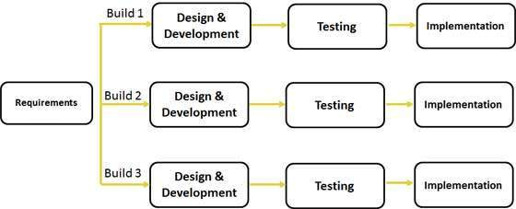

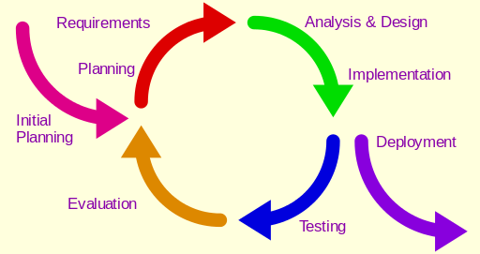

**2.5.2 Feasibility Study**

**Economic feasibility**

Economic feasibility attempts to weigh the cost of developing and implementing a new system, against the benefits that would accurate from having the new system in place. This feasibility study gives the top management the economic justification for the new system

A simple economic analysis which gives the actual comparison of costs and benefits are much more meaningful in this case. In addition, this proves to be a useful point of reference to compare actual costs as the project progresses. There could be various types of intangible benefits of account of automation. These could include increased customer satisfaction, improved accuracy of operation, better documentation and record keeping, faster retrieval of information.

**Schedule feasibility**

Schedule Feasibility means that the project can be completed on time

The project does not have a deadline but according to the proposed system the development process is on schedule. Therefore it is feasible.

**Operational feasibility**

Proposed project is beneficial only if it can be turned into information systems that will meet the organization operating requirements. Simply stated, this test of feasibility asks if the system will work when it is developed and installed. What are major barriers to implementation? Here are questions that will help test the operational feasibility of a project

**Technical feasibility**

Technical feasibility centers on the existing computer system(hardware, software, etc. ) and to what extent it can support the proposed addition. For example, if the current computer is operating at 80% capacity-an arbitrary ceiling-then running another application could overload the system or require additional hardware. This involves financial considerations to accommodate technical enhancements. If the budget is a serious constraint, then the project is judged but not feasible.

**2.5.3 Gantt Chart**

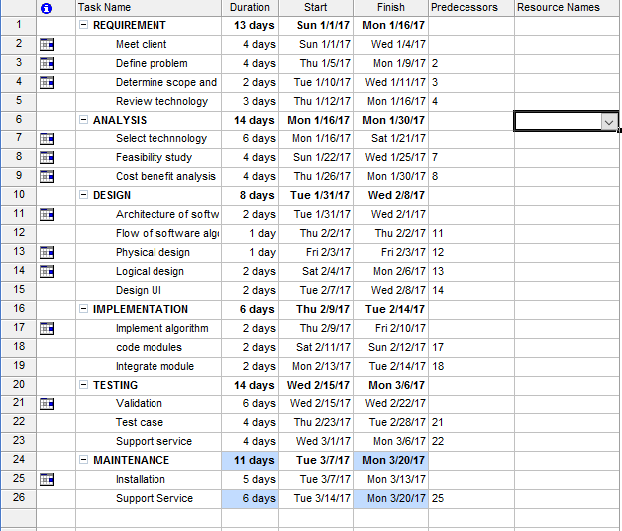

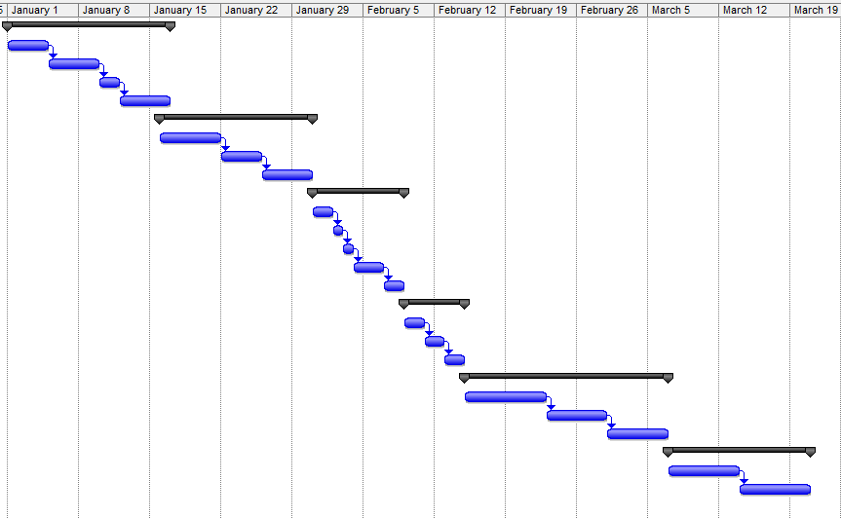

**SYSTEM DESIGN PHASE**

**2.6.1 Data Flow Diagram:**

**Level 0 :**

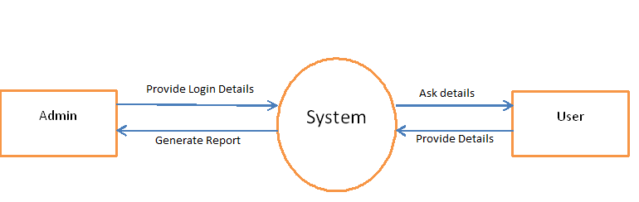

**Level 1:**

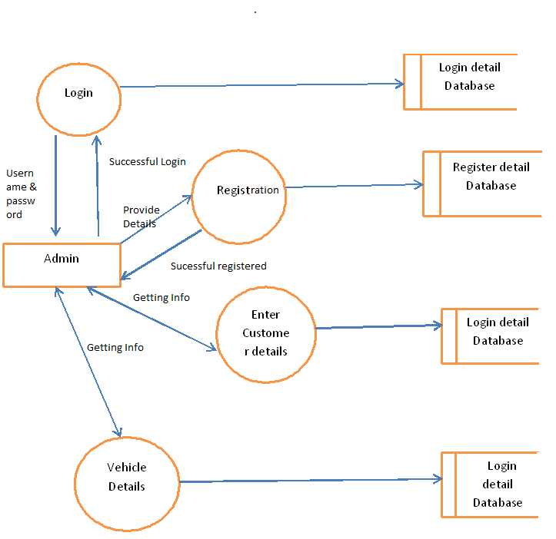

**Level 2:**

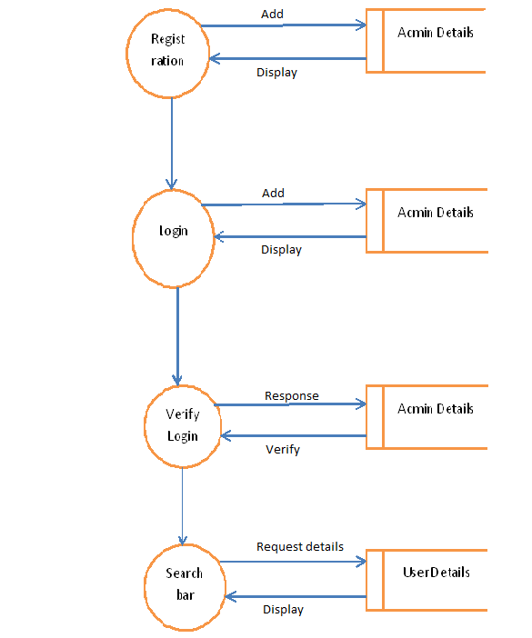

**2.6.2 ER-Diagram**

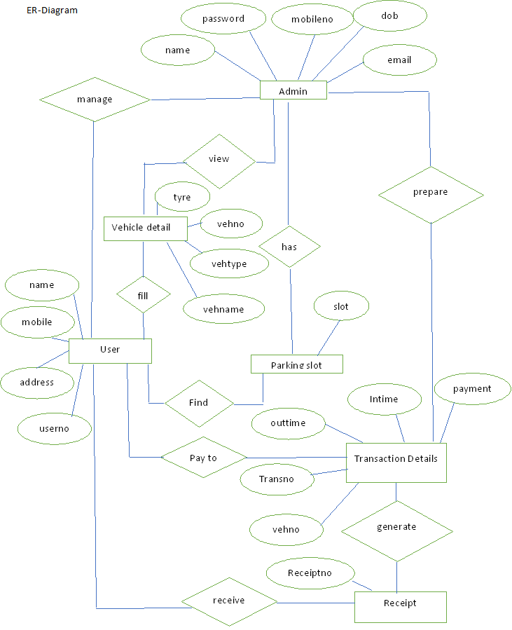

**2.6.3 Class diagram**

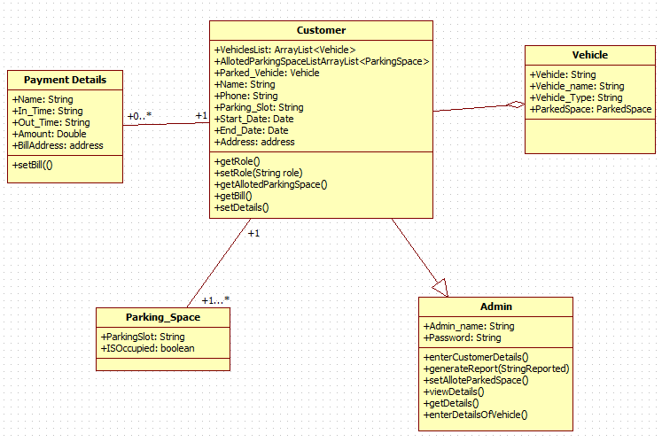

**2.6.4 Use case Diagram**



**2.6.5 Activity Diagram**



**2.6.6 Sequence diagram**

. 

**SYSTEM IMPLEMENTATION**

**PHASE**

**2.7.1 Cost Benefit Analysis:**

Cost benefit analysis (CBA) estimates and total up the equivalent money value of the benefits and the cost invested to for implementation the software .Cost benefit analysis (CBA) is the weighing scale approach to decision-making. All the plus points (such as cash flow and other intangible benefits) are put on one side all the minus points (the cost and disadvantages) are put on the other side. Both sides should be weighed and benefits should be evaluated.

**Cost Estimation:**

A **cost estimate** is the approximation of the **cost** of a program, project, or operation. The **cost estimate** is the product of the **cost estimating** process. The **cost estimate** has a single total value and may have identifiable component values.

For a given set of requirements, it is desirable to know how much it will cost to develop the software to satisfy a given requirement, and how much time development will take. The cost of a project is a function of many parameters. Foremost among them is the size of the project. Other factors that effects the cost are programmer ability, experience of the developers in the area , complexity of the project, and reliability requirements of the software, hardware and human resources

**Benefits:**

* Improves business processes leading to annual cost decrease.
* Due to availability of information, better decision making is possible leading to additional cash flows.

**Development Cost:**

|  |  |  |
| --- | --- | --- |
|  | Tools Requirement | Cost |
| **Hardware** | 1 Computer | 29000 |
|  | Installation Charges | 2000 |
|  | **Total** | 31000 |
| **Software and Licenses** | Asp. Net (Visual studio 2015) | 5000 |
|  | SQL Server 2008 | 2000 |
|  | **Total** | 7000 |

**Operational cost**

|  |  |  |
| --- | --- | --- |
| Tools Name | Maintenance | Cost |
| Operational | Hardware Maintenance | 2500 |
|  | Software Maintenance | 2500 |
|  | Total | 5000 |

2.7.2 User Interface

1. **Admin Login**

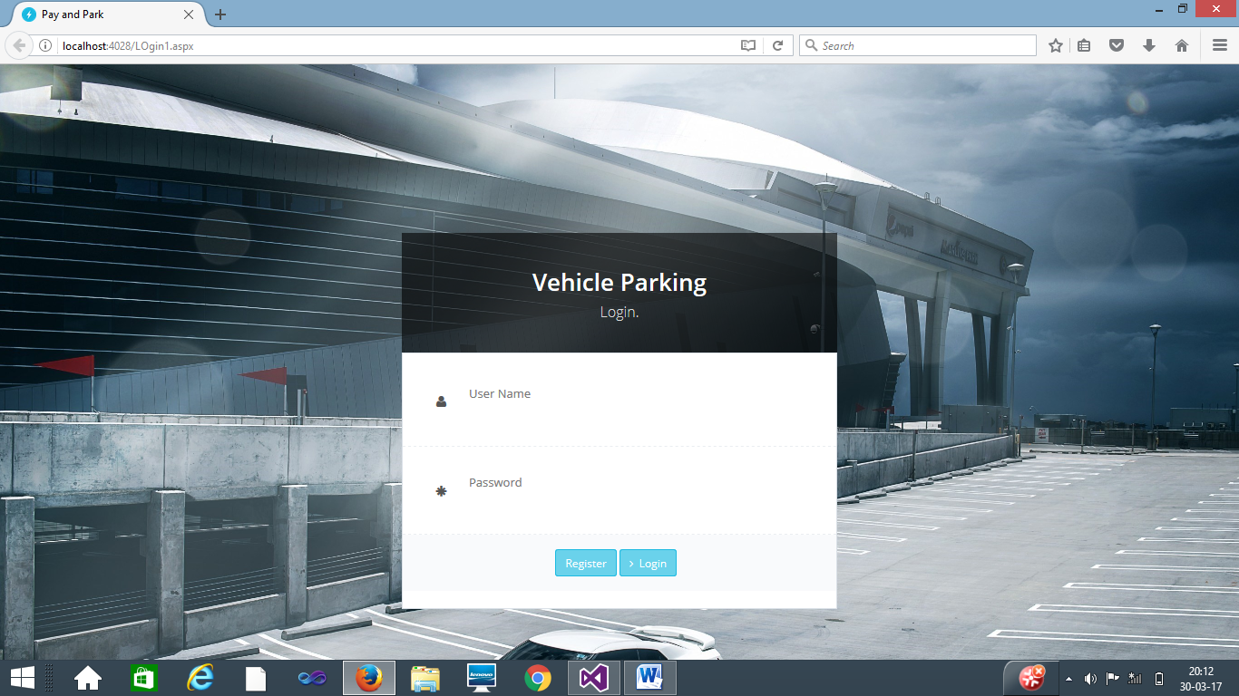

1. **Invalid login and password**

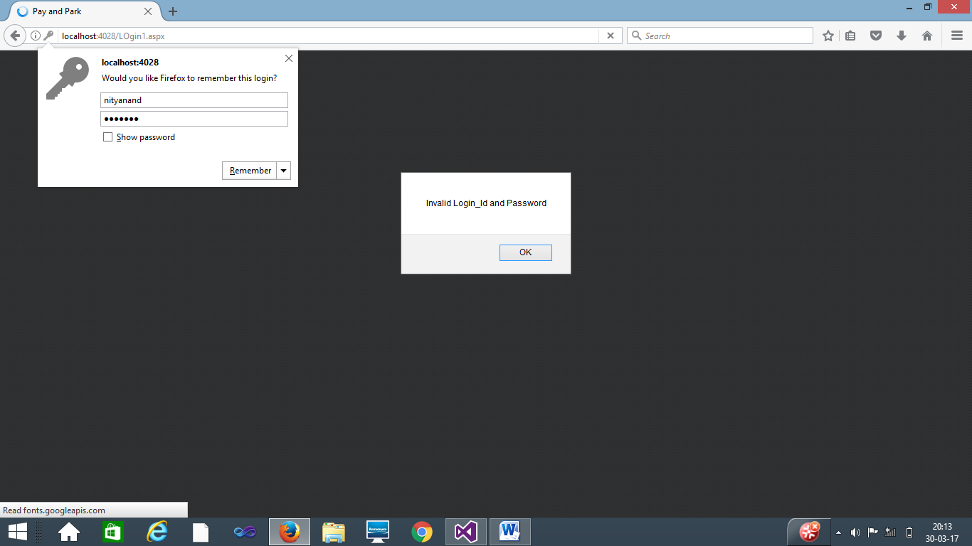

1. **Password required field error**

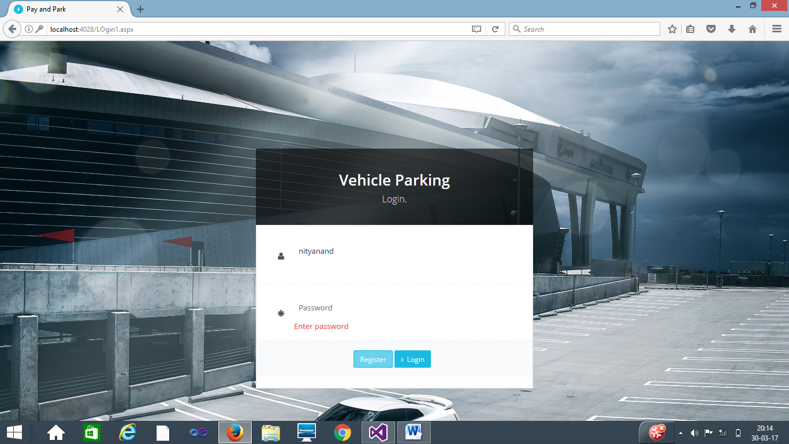

1. **Register page**

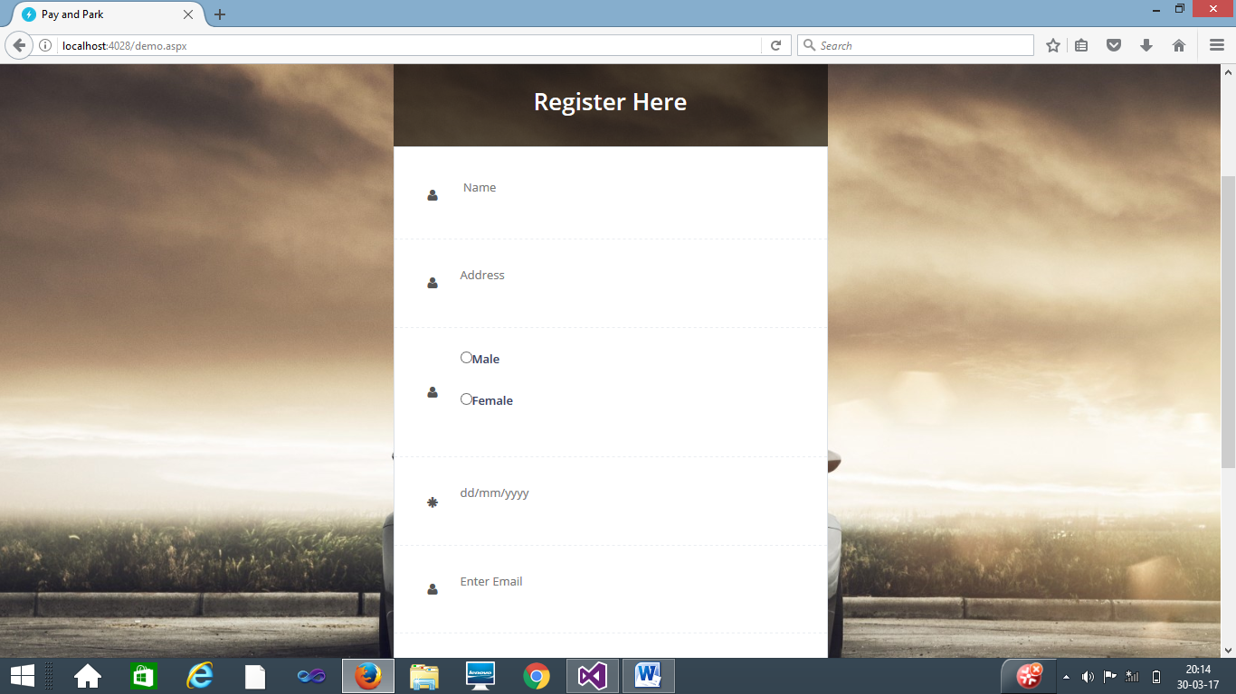

1. **Registration successful prompt**

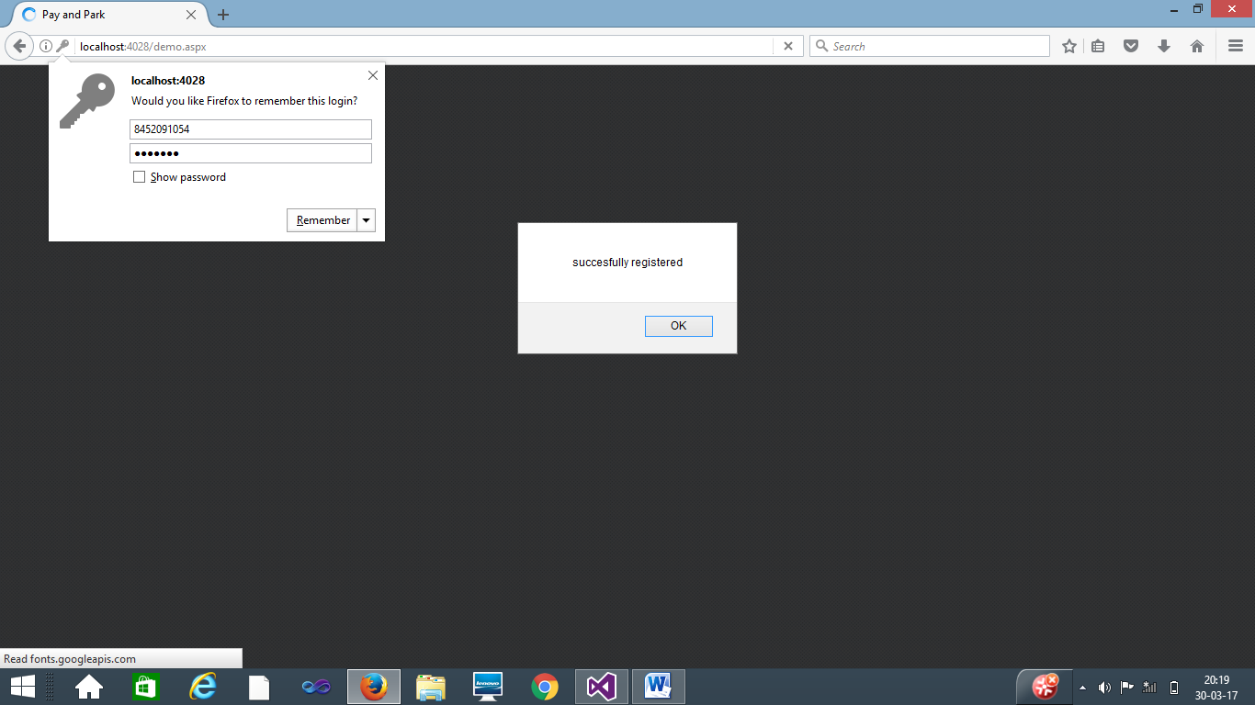

1. **Admin logout**

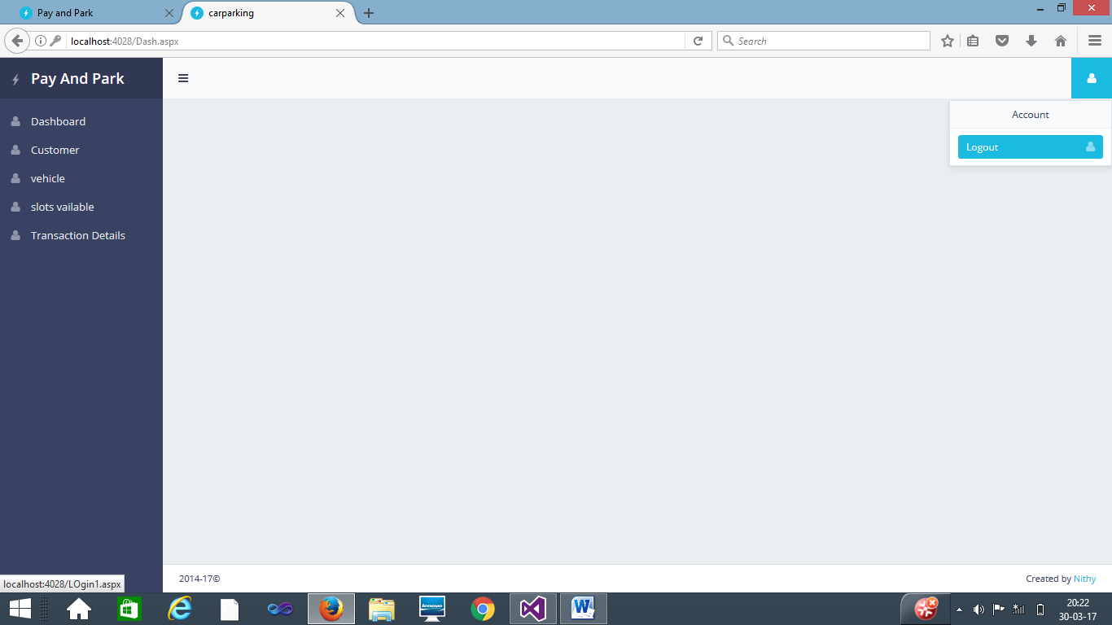

1. **Search for customer Details**

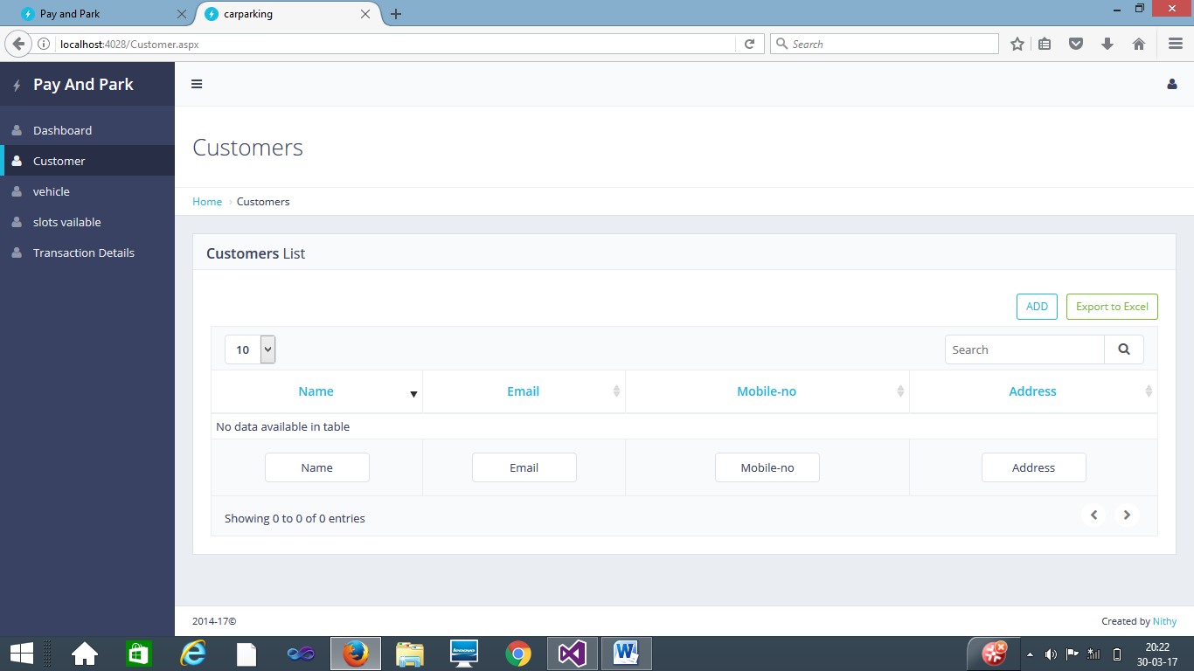

1. **Add and Update customer**

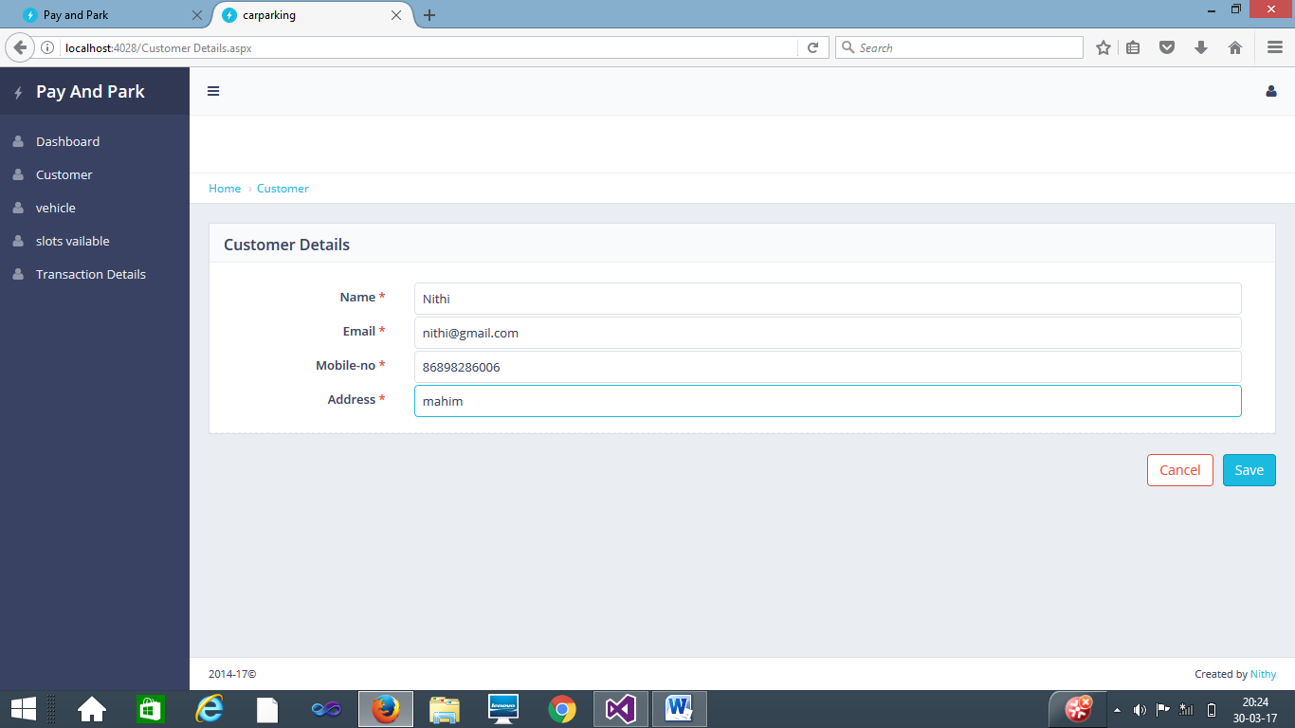

1. **Search for vehicle details**

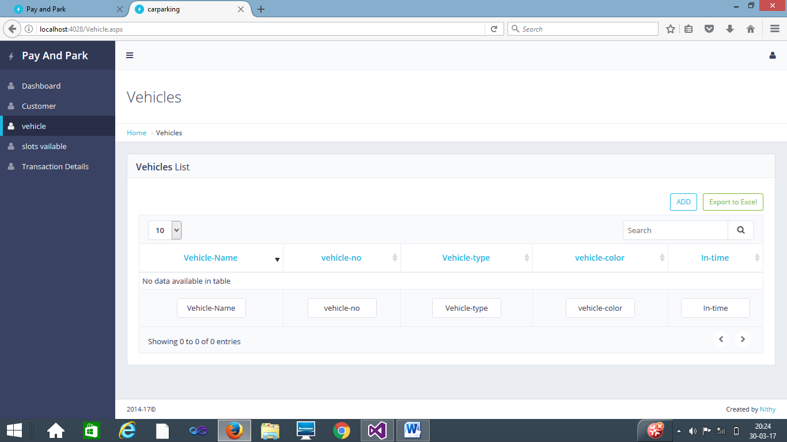

1. **Add and Update vehicle details**

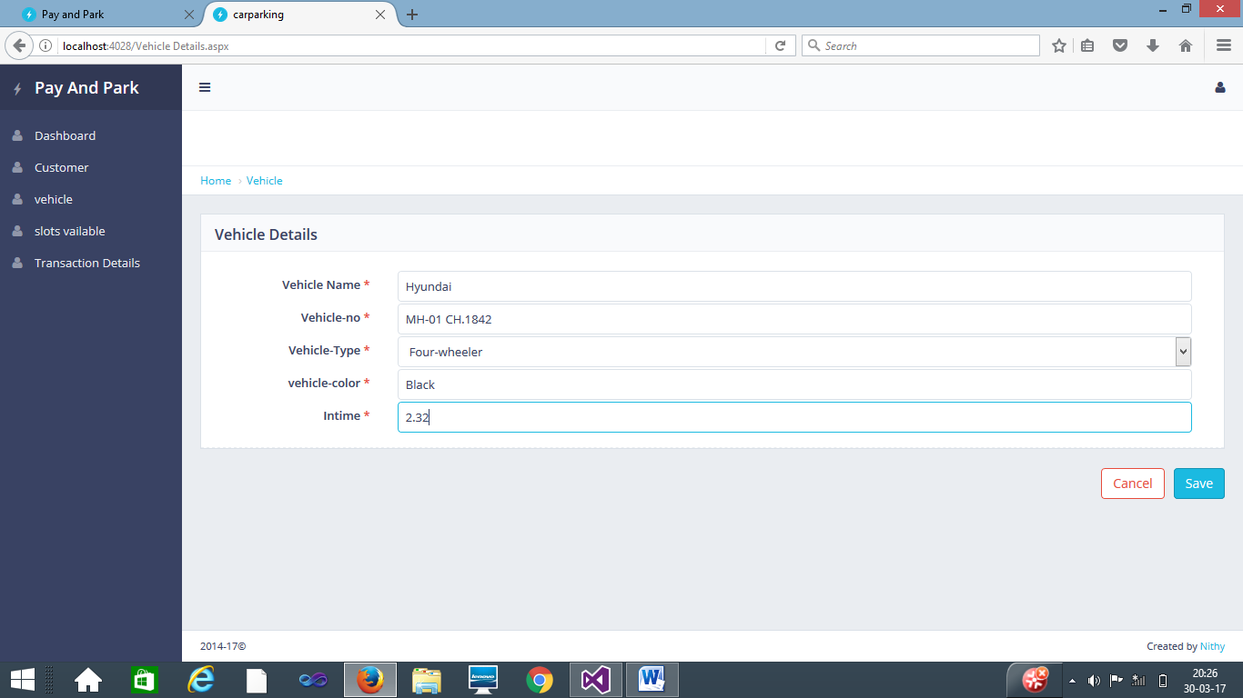

2.7.3 Database Snaps

**1. Login database**

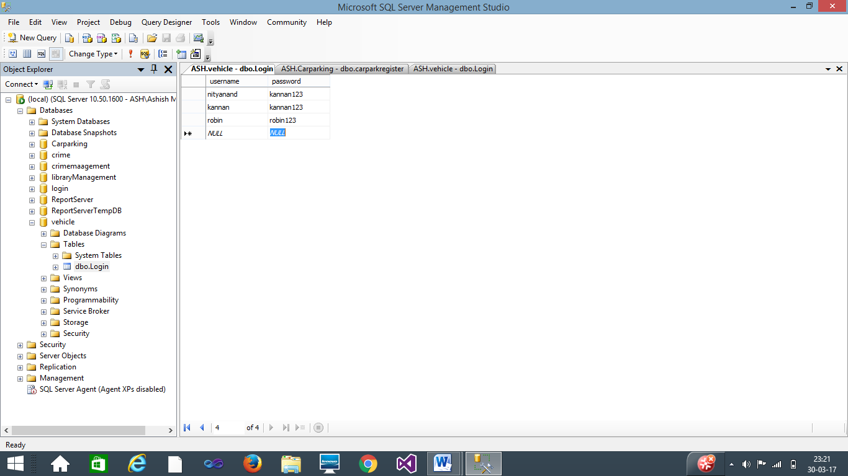

**2. Register database**

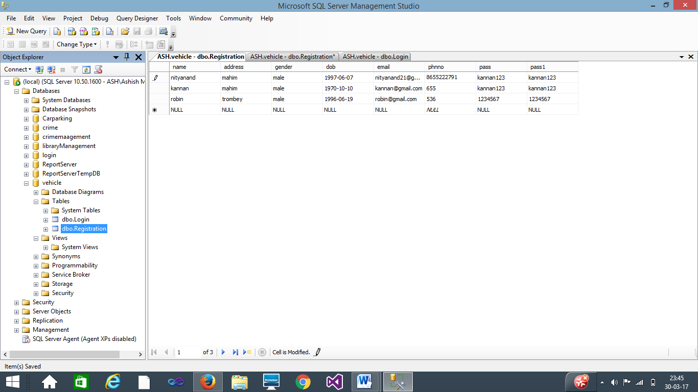

**3. Add Customer**

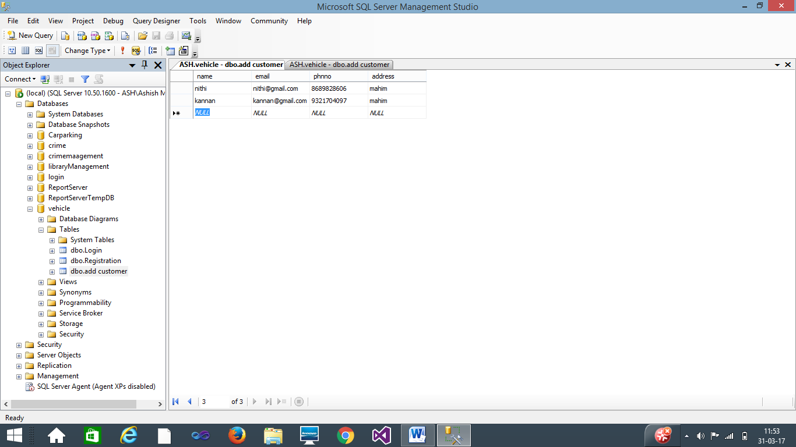

**4. Add Vehicle**

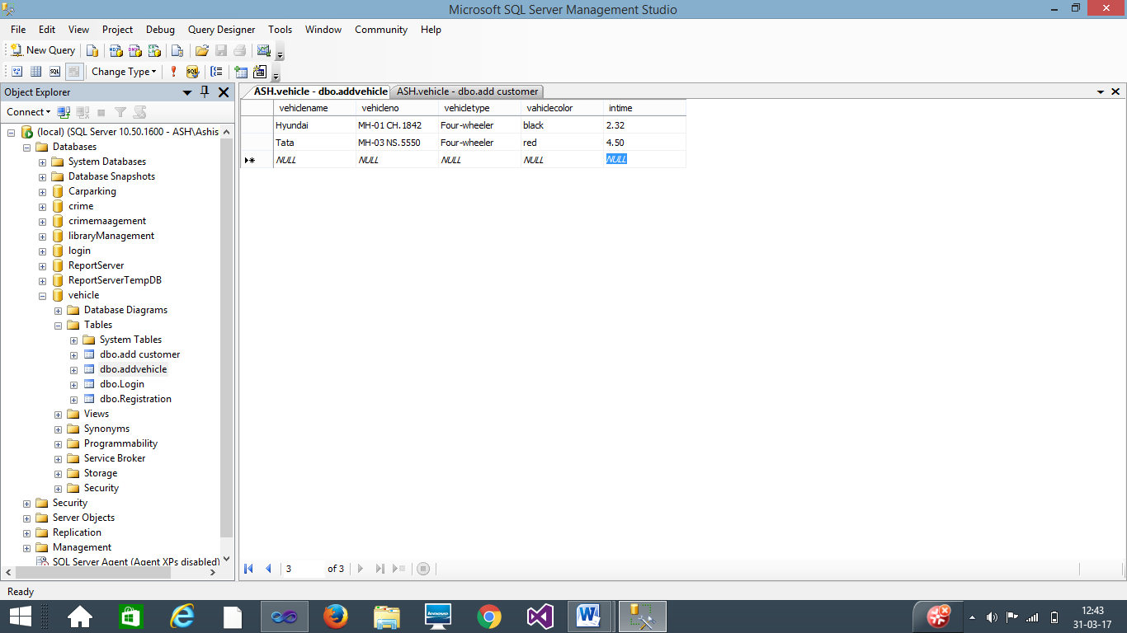

**SYSTEM MAINTENANCE**

**System Maintenance And Evaluation:**

System Maintenance is a modification of the software product after delivery to accomplish one of the following objectives:

* Correct faults.
* Improve the performance or other attributes
* Adapt the product to the change environment

The term support and maintenance describes activity that occur after a system is made operational. Support activities assist users in realizing the full benefits of the system. It ensures that the system function at peak efficiency and the needed changes are implemented with minimal disruption to the organization.

The performance of the system can be measured by two factors, viz. the efficiency and effectiveness. The efficiency indicates the manner in which the inputs are used by the system .If the input-output ratios is adverse, we say that the system is inefficient though it produces the desired output or not .When the system is ineffective, the system is out of control and it needs a major correction. A system has to be effectiveness is a measure of the productivity i.e. the measure of the output against the input.

Throughout the Lifecycle of the project it is put through test against efficiency and effectiveness quite frequently. The stronger the system is, the lesser maintenance the system requires. As of now ,there is no significant maintenance policy adopted or proposed for the system.

**Security:**

The system security problem can be divided into four relates issues: security, integrity, privacy and confidentiality. They determine the file structure, data structure and access procedures.

**system security** An (operating) system is responsible for controlling access to system resources, which will include sensitive data. The system must therefore include a certain amount of protection for such data, and must in turn control access to those parts of the system that administer this protection. System security is concerned with all aspects of these arrangements.

System Integrity

State of a system where it is performing its intended functions without being degraded or impaired by changes or disruptions in its internal or external environments.  
  
That condition of a [system](https://en.wikipedia.org/wiki/System) wherein its mandated operational and technical parameters are within the prescribed limits.

The state that exists when there is complete assurance that under all conditions an [IT](https://en.wikipedia.org/wiki/Information_technology) system is based on the logical correctness and reliability of the [operating system](https://en.wikipedia.org/wiki/Operating_system), the logical completeness of the [hardware](https://en.wikipedia.org/wiki/Computer_hardware) and [software](https://en.wikipedia.org/wiki/Software) that implement the protection mechanisms, and [data integrity](https://en.wikipedia.org/wiki/Data_integrity).

Confidentiality, integrity and availability, also known as the CIA triad, is a model designed to guide policies for information security within an organization. The model is also sometimes referred to as the AIC triad (availability, integrity and confidentiality) to avoid confusion with the Central Intelligence Agency.

**SYSTEM TESTING PHASE**

**Testing Process**

Testing is a process to show the correctness of the program. Testing is needed to show completeness, it improve the quality of the software and to provide the maintenance aid. Some testing standards are therefore necessary reduce the testing costs and operation time. Testing software extends throughout the coding phase and it represents the ultimate review of configurations, design and coding. Based on the way the software reacts to these testing, we can decide whether the configuration that has been built is study or not. All components of an application are tested, as the failure to do so many results in a series of bugs after the software is put to use.

* **Black box Testing**

Black box testing, also called behavioural testing, focuses on the functional requirements of software. This testing approach enables the software engineer to derive the input conditions that will fully exercise all requirements for a program. Black box testing attempts to find the errors like

* Incorrect or missing functions
* Interface errors
* Errors in data structures or external database access
* Behaviour or performance errors
* Initialization and termination errors

In Black box testing software is exercised over a full range of inputs and outputs are observed for correctness.

* **White box Testing**

White box testing is also called Glass box testing is a test case design control; structure of the procedural design to derive test cases using White box testing method, the software engineer can derive the test cases that guarantee that all independent paths within the module have been exercised at least once. Exercise all logic decisions on their true or false sides. Execute all loops at their boundaries and within their operational bounds. Exercise internal data structure to ensure their validity.

* **Software Testing Strategies**

Testing involves

* Unit testing
* Integration testing
* Acceptance testing

The first level of test is unit testing. The purpose of unit testing is to ensure that each program is fully tested.

|  |  |  |
| --- | --- | --- |
| **Attributes** | **On Module/Page** | **Validation** |
| Name, Phone, Email-id, address, DOB, Gender | Admin Registration | Should be not null |
| Password, Retype Password | Admin Registration | Should match the password |
| Username, Password | Login | Should match with the system database |
| Vehicle Details | Update Vehicle details | Must be Retrieved from the database |
| Customer details | View Customer details | Should retrieve from the database |

The second step is integration testing. In this individual program units or programs are integrated and tested as a complete system to ensure that the software requirements are met.

Acceptance Testing involves planning and the execution of various types of tests in order to demonstrate that the implemented software system satisfies the requirements. Finally our project meets the requirements after going through all the levels of testing.

**Validation:**

**SYSTEM TEST REPORT**

**Test Cases**

Test Cases are good in revealing the presence of faults. Successful in implementation of test cases implies that there are no error in program. Test cases should be minimum as they are expensive in case of money & efforts. Primary objectives of test cases are to ensure that if there is an error or fault in program it is exercise by the test cases. An ideal test case set is one that succeeds only if there are no errors in the program. One possible ideal set of test case is one that includes all possible I/P to the program and is called exhaustive testing. A test case is good if it detect in undiscovered error in program.

1. **Login**

|  |  |  |  |  |
| --- | --- | --- | --- | --- |
| **Sr. No** | **Input values** | **Expected Output** | **Actual Output** | **Result** |
|  | Login in without User name and password | Error message and directed to same page | Error message and directed to same page | No Error |
|  | If User is new, click on register button | Will go to new form | Will go to new form | No Error |
|  | Incorrect User Id or Password | Error message and directed to same page | Error message and directed to same page | No Error |

1. **Admin**

|  |  |  |  |  |
| --- | --- | --- | --- | --- |
| **Sr. No** | **Input values** | **Expected Output** | **Actual Output** | **Result** |
| 1 | Login in without entering User name and password | Error message Enter a valid  User id and password | Error message Enter a valid  User id and password | No Error |
| 2 | Login with wrong User Id and password | Error Message | Error Message | No Error |
| 3 | Correct User Id and password | Directed to Admin Page | Directed to Admin Page | No Error |
| 4 | Click on All Dashboard | Show all Dashboard | Show all Dashboard | No Error |
| 5 | Click on view customer details | Show all customer details | Show all customer details | No Error |
| 6 | Update Vehicle details | Must be Retrieved from the database | Must be Retrieved from the database | No Error |
| 7 | Logout | Directed to the admin login page | Directed to the admin login page | No Error |

**CONCLUSION**

**Conclusion**

This Project is minimizing the task of parking a vehicle by paying and saying some details about customer and vehicle to save data .In this the vehicle is parked as a safe and secure. This project is done as Efficient as possible

Hereby I, the Student of BSc(IT) 6th Semester concludes that the project was completely and slowly developed by me. I also conclude that this project has helped us gain more knowledge about the topic that we are indulged ourselves into “ Visual Studio ”. I would be glad to enhance and promote this project if given chance and help ourselves and society in the near future

The developed application is tested with sample inputs and outputs obtained in according to the requirement. Even though I have tried our level best to make it a dream project. Due to time constraints I could not add more facilities to it.

The efficiency of the developed system can be enhanced with some minor modifications. Future development can be made in proposed system by integration more services like:

* It can be implemented through web pages.
* New effectives modules can be added time to time

**SYSTEM FUTURE**

**ENHANCEMENT**

**Scopes For Expansion**

This is the modern age. Many people have vehicles. Vehicle is now a basic need. Every place is under the process of urbanization. There are many corporate offices and shopping centers etc. There are many recreational places where people used to go for refreshment. So, all these places need a parking space where people can park their vehicles safely and easily. Every parking area needs a system that records the detail of vehicles to give the facility. These systems might be computerized or non-computerized. With the help of computerized system we can deliver a good service to customer who wants to park their vehicle into the any organization’s premises.

**Enhancement to create a Bigger and Better System**

These enhancements deal with what would be required in a new improved, bigger and better system

* In future if when a vehicle enters into the parking area there should be one sensor in which the user can easy identify from outside only Is there parking is full or empty or space is allocated.
* In future the vehicle can be parked by machines

**ANNEXURE**

**2.13.1 Data Dictionary**

**Login:**

|  |  |  |  |
| --- | --- | --- | --- |
| **Field** | **Description** | **Type** | **Constraints** |
| Username | Name | Varchar(25) | Not null |
| Userpass | Password | Varchar(25) | Not null |

**Register:**

|  |  |  |  |
| --- | --- | --- | --- |
| **Field** | **Description** | **Type** | **Constraints** |
| Name | Name | Varchar(25) | Not null |
| Address | Address | Varchar(50) | Not null |
| Gender | Gender | Varchar(10) | Not null |
| DOB | DOB | Date | Not null |
| Email | Email | Varchar(25) | Not null |
| Password | Password | Varchar(25) | Not null |
| Re-Password | Re-Password | Varchar(25) | Not null |

**Add & Update Customer:**

|  |  |  |  |
| --- | --- | --- | --- |
| **Field** | **Description** | **Type** | **Constraints** |
| Name | Name | Varchar(25) | Not null |
| Email | Email | Varchar(25) | Not null |
| Phone no | Phnno | Varchar(25) | Not null |
| Address | Address | Varchar(50) | Not null |

**Add & Update Vehicle:**

|  |  |  |  |
| --- | --- | --- | --- |
| **Field** | **Description** | **Type** | **Constraints** |
| VehicleName | Vehname | Varchar(25) | Not null |
| VehicleNo | Vehno | Varchar(25) | Not null |
| VehicleType | Vehtype | Varchar(25) | Not null |
| VehicleColor | Vehcolor | Varchar(25) | Not null |
| Intime | intime | Varchar(25) | Not null |

**2.13.2 Bibilography**

[www.google.co.in](http://www.google.co.in)

[www.w3schools.com](http://www.w3schools.com)

[www.youtube.com](http://www.youtube.com)

[www.DocFoc.com](http://www.DocFoc.com)

[www.SlideShare.com](http://www.SlideShare.com)

[www.codeproject.com](http://www.codeproject.com)